**Detailed Longevity/Stability Summary Report**

**BlogEngine**

Testing was conducted on following hardware specs:

Cpu 8 cores, RAM 16 Gb

**Capacity testing**

Capacity testing was performed to determine the saturation points of the application.

Capacity testing results:

Saturation point – 2 vusers, 1900 req/sec

Throughput capacity test results chart:

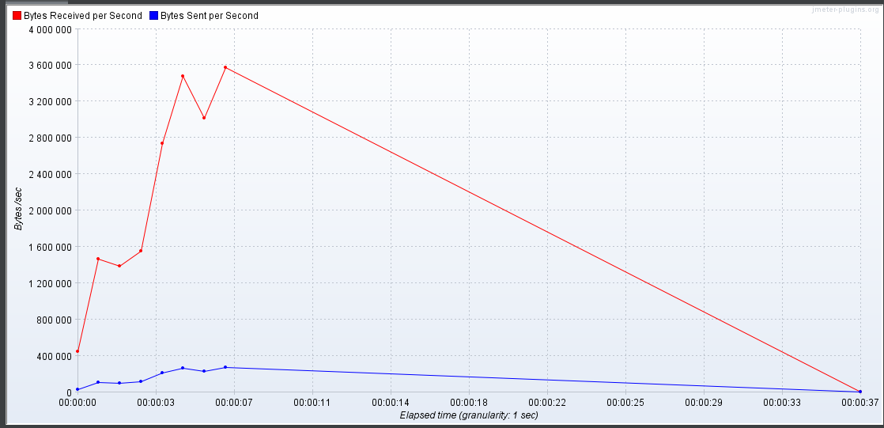

Response times:

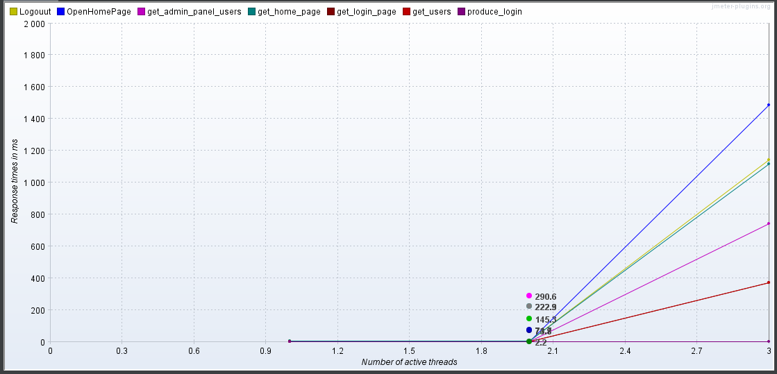

**Performance Issues**

**Several performance issues were found based on all conducted testing types:**

1. **Significant response time degradation after 2 concurrent editor users during longevity test execution**
2. **Crash of the application and it’s not able to restore by itself**

**Fixed-load Longevity/Stability testing based on Capacity testing results**

Throughput(avg): 1900 bytes/sec, 2vuser, 1000 posts

